

Name : Adil Khan
Roll No : 2330-0030
Dept: BS AI
Subject: Data Base system

Task NO 1:
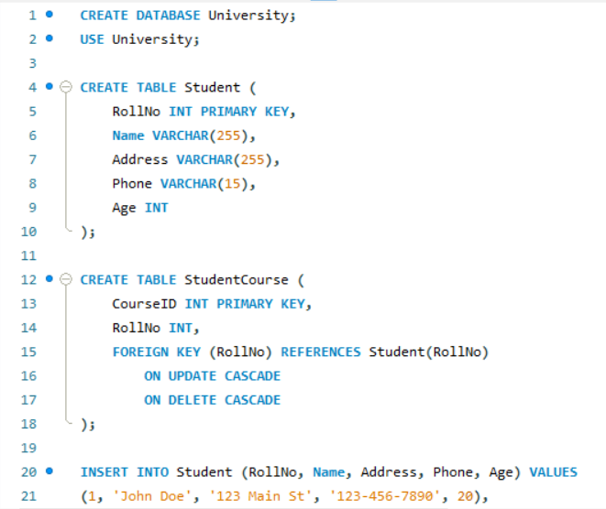

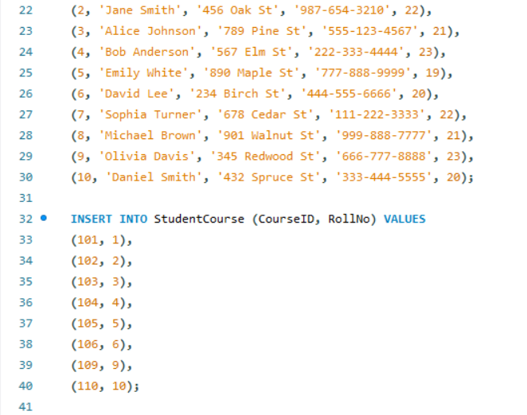

- INNER JOIN(EQUI JOIN)
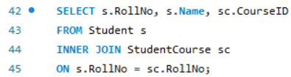

Output:
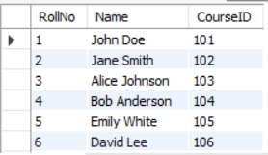

- LEFT JOIN (LEFT OUTER JOIN)
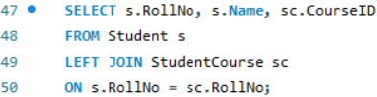

Output:
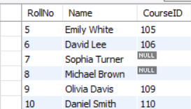

- RIGHT JOIN (RIGHT OUTER JOIN)
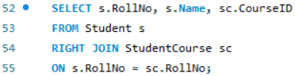

Output:
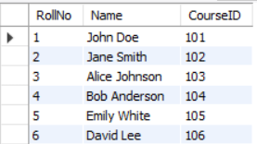

- FULL JOIN (FULL OUTER JOIN)
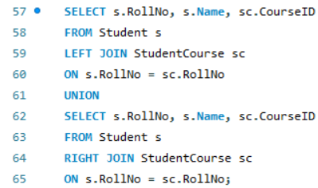

Output:
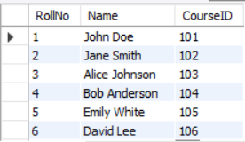

- CROSS JOIN
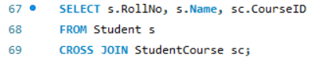

Output:
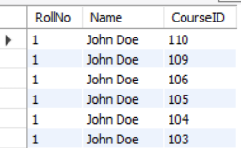

- SELF JOIN
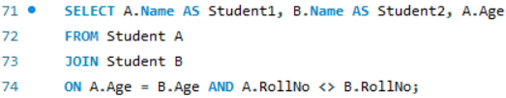

Output:
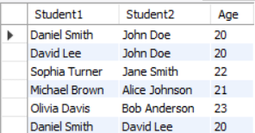

- NATURAL JOIN
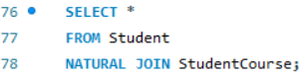

Output:
